AGENDA
Develop Decarbonising Pathways for Urban Passenger Transport:
the ITF approach
Pre-kickoff and traiNing workshop
18-19 November 2021

Zoom link – Your living room
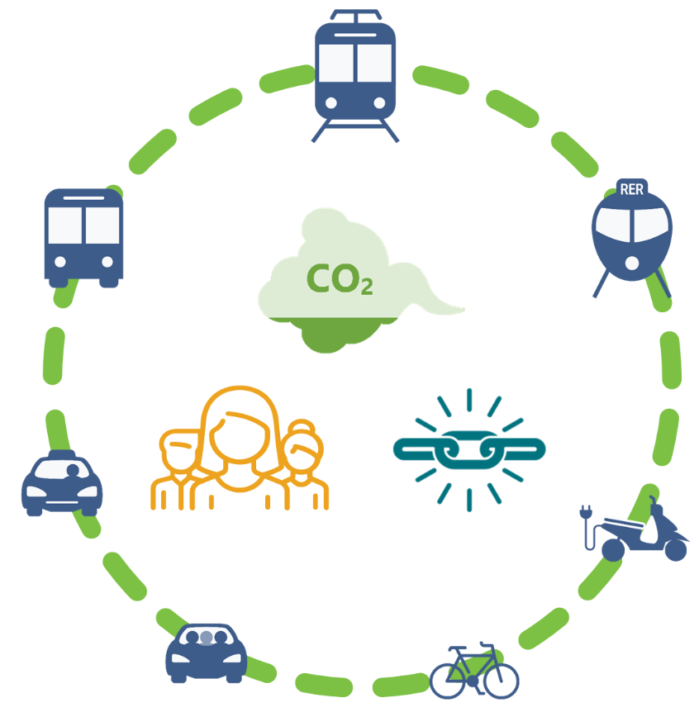

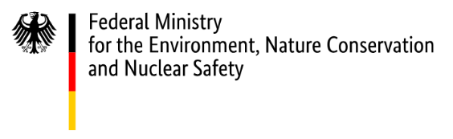

INTERNATIONAL TRANSPORT FORUM
The International Transport Forum (ITF) at the OECD is an intergovernmental organisation with 63 member countries. It acts as a think tank for transport policy that covers all modes of transport. The ITF’s mission is to foster a deeper understanding of the role of transport in economic growth, environmental sustainability and social inclusion and to raise the public profile of transport policy. The ITF acts as a platform for discussion of transport policy issues. It analyses trends, shares knowledge and promotes exchange among transport decision-makers and civil society.
ABOUT THE PROGRAMME
In the context of the economic recovery phase of the Covid-19 crisis, the OECD is leading a new 4-year programme (2021-2025) in Central Asia and Southeast Asia to encourage the transition towards cleaner energy, transport and industrial systems through better alignment of infrastructure investment projects with the Paris Agreement and the Sustainable Development Goals.
The project is targeting public and private stakeholders for infrastructure planning, financing and delivery in the following countries of implementation: Kazakhstan, Mongolia, Uzbekistan, Indonesia, Thailand, the Philippines and China.
The project will deliver the following Outputs:
- Output I - Strategic infrastructure planning and project evaluation: Providing policy reviews, training programmes, aimed at improving in-country capacity in aligning strategic infrastructure planning and project-level assessment methodologies with long-term low-carbon, resilient and inclusive development pathways;
- Output II - National framework conditions: Developing roadmaps and strategies for low-emission energy, transport and industry sectors, aimed at enhancing sectoral policy framework;
- Output III - Mobilising financiers and businesses: Providing capacity building activities, policy dialogues and country reviews and recommendations, aimed at promoting sustainable finance and Responsible Business Conduct (RBC) principles within governments, financiers and relevant business sectors; and
- Output IV - Regional peer-learning and knowledge management: Establishing regional peer-learning networks, high-level policy dialogue events, and training programmes on sustainable infrastructure planning and financing in Southeast Asia and Central Asia regions.

TRANSPORT ACTIVITIES OF THE PROGRAM
The ITF is leading the transport sector of the programme, focusing on sustainable transport infrastructure development in the Central Asia (CA) and Southeast Asia (SEA) regions. The proposed activities for the transport sectors cover both regional- and national-scale studies for both regions.
- Regional-level: ITF will assess regional large-scale transport infrastructure programmes for both CA and SEA regions, their capacity to improve connectivity and their environmental externalities. This work will entail stocktaking of all current and potential future transport infrastructure projects in the region, and scenario analysis to identify the impact of different infrastructure options. Outcomes of the impact analyses will enable identifying whether or not infrastructure gaps exist in the future, and if they exist, what are the best strategies to finance the gaps. It will also include benchmarking of national freight transport policies against OECD best practices, focusing on opportunities to reduce CO2 emissions from the construction and use of the respective infrastructure (life cycle assessment approach).
- National-level: ITF will develop a sustainable transport roadmap with a specific focus tailored to the country’s needs. Initial consultation activities will help identify the focus of the roadmap (i.e. with regards to which transport sub-sector (passenger/freight transport), geographic scope (urban/non-urban), mode of transport (rail/road/aviation/shipping), or specific technology or policy implementations).
NATIONAL ROADMAP STUDY FOR MONGOLIA
The national roadmap study for Mongolia focuses on developing decarbonising pathways for urban passenger transport in Ulaanbaatar, Mongolia, with a particular focus on the role of public transport development. The activity of this study is composed of three Parts:
- Part 1: Understanding the urban transport context in Ulaanbaatar - Part 1 aims to understand the current situation about urban transport systems in Ulaanbaatar, including policy priorities and ongoing initiatives. Part 1 also contains an element of data collection.
- Part 2: Quantitative assessment of decarbonising pathways for Ulaanbaatar - This part of the project aims to find effective pathways for reducing CO2 emissions by making use of the existing modelling framework developed by the ITF. It will build on the ITF’s urban transport model and construct a tailored modelling tool for Ulaanbaatar, allowing the assessment of the impact of various policies and measures (particularly, public transport development) on transport demand, mode shares and CO2 emissions, public transport coverage, and local pollution at the city level.
- Part 3: Dissemination of best practices about low-carbon transport systems - The main work under Part 3 is the dissemination of the scenario building tool and the policy findings, as well as the best practices identified during the work, in particular among other interested stakeholders in Mongolia or Central Asia region. To this end, one joint workshop will be organized by the ITF and MRTD/UB city in Ulaanbaatar, inviting a wide range of participants.
WORKSHOP FOR GROUND-SETTING
The Workshop will take place on the 18th-19th of November 2021. It is a closed (by invitation only) event, questions and discussions are welcome along with the presentations. The webinar will take place virtually using the teleconferencing platform Zoom.
The webinar will gather key stakeholders from the urban transport sector in Ulaanbaatar and Mongolia in general, such as the Ministry of Road and Transport, the city of Ulaanbaatar, transport authorities, industry, academia, NGOs and international organisations. The workshop objectives are to:
- Pre-kickoff the national roadmap study for Ulaanbaatar, Mongolia
- Share the ITF approach on developing decarbonising pathways for urban passenger transport to
  - ensure a common understanding of key concepts, the capacities, and limitations of the ITF approach,
  - showcase previous relevant projects to identify potential outputs for Ulaanbaatar.

ZOOM LINK FOR THE WORKSHOP

The zoom links will be edited and provided once the agenda is validated.

Some useful information:
- A headset with a microphone is recommended or an audio system with echo canceler
- A wired internet connection is recommended
- Please mute your microphone throughout the meeting, except when you wish to take the floor and speak

Personal Data protection
The OECD processes personal data under its Personal Data Protection Rules: https://www.oecd.org/general/data-protection.htm

Security and Privacy
The OECD’s configuration of the Zoom service reflects the following measures:
- Pre-registration, passwords, and the “waiting room” functions are enabled to prevent unauthorised access to the conference.
- Specific identity format (country, name) for remote participants for easy control of each attendee in the Waiting Room before admitting them into the meeting.
- Only the host (OECD) or co-hosts can enable a recording on their local computers.
- If the conference is recorded, a notice will show on the screen.
- No chats can be saved, and no private chats are permitted, except with the host or co-hosts.
- Participants enter the conference call muted and without video showing, unless and until they enable these features themselves.
- Avoid discussing any highly-sensitive matters

AGENDA
DAY 1 PROGRAM
18 November, 16:30 – 19:00 Ulaanbaatar time (UTC+8) / 9:30 – 12:00 Paris time (UTC+1)
Moderator: Mallory Trouvé, Policy Analyst/Modeller, ITF

16:15 – 16:30  9:15 – 9:30 | Meeting start – connection to Zoom platform  Zoom meeting guidelines
16:30 – 17:25  9:30 – 10:25 | Welcome and Introduction
- Welcome remarks (5 minutes)
Jari Kauppila, Head of Quantitative Policy Analysis and Foresight, ITF
- Welcome remarks (5 minutes)
Elaine Conkievich, Resident Representative at UNDP Mongolia.
- Welcome remarks (5 minutes)
Ministry representative (TBC)
- Tour de Table (10 minutes)
- About the IKI Sustainable Infrastructure Program (10 minutes)
Guineng Chen, Team Lead, ITF
- About the National Roadmap Study For Mongolia (10 minutes)
Mallory Trouvé, Policy Analyst/Modeller, ITF
- Mongolia’s Involvement/Commitment (10 minutes)
Ministry representative (TBC)
17:25 – 17:35  10:25 – 10:35 | Break
17:35 – 19:00  10:35 – 12:00 | The ITF approach to Developing Decarbonising Urban Transport Pathways, Part I (1 hour 25 minutes)
- Transport Modelling to Support Policy Making (60 minutes)
Yaroslav Kholodov, Policy Analyst/Modeller, ITF
Mallory Trouvé, Policy Analyst/Modeller, ITF
Discussion – 25min
19:00  12:00 | End of day 1

DAY 2 PROGRAM
19 November, 16:30 – 19:00 Ulaanbaatar time (UTC+8) / 9:30 – 12:00 Paris time (UTC+1)
Moderator: Mallory Trouvé, Policy Analyst/Modeller, ITF

16:15 – 16:30  9:15 – 9:30 | Meeting start – connection to Zoom platform  Zoom meeting guidelines
16:30 – 17:55  9:30 – 10:55 | The ITF approach to Developing Decarbonising Urban Transport Pathways, Part II (1 hour 25 minutes)  - Aggregated urban transport modelling at the city level: a case study in India (30 minutes + 5 minutes Q&A)  Guineng Chen, Team Lead, ITF  - Disaggregated urban transport modelling at the zone level: a case study in Latin America (30 minutes + 5 minutes Q&A)  Mallory Trouvé, Policy Analyst/Modeller, ITF  Discussion (15 minutes)
17:55 – 18:05  10:55 – 11:05 | Break
18:05 – 18:50  11:05 – 11:50 | The ITF approach to Developing Decarbonising Urban Transport Pathways, Part III (45 minutes)  - Strategies for Public transport planning (30 minutes)  Orla McCarthy, Policy Analyst/Modeller, ITF  Discussion (15 minutes)
18:50 – 19:00  11:50 – 12:00 | Closing remarks  Guineng Chen, Team Lead, ITF
19:00  12:00 | End of day 2
LIST OF PARTICIPANTS
Name |  |  | Organisation
XX | Ministry of Road and Transport, MNG
YY | City of Ulaanbaatar
ZZ | UNDP CO Mongolia
International Transport Forum
Jari Kauppila | Head of QPA Division, Head of SG Office
Guineng Chen | Team Lead
Mallory Trouvé | Policy Analyst/Modeller
Yaroslav Kholodov | Policy Analyst/Modeller
Orla McCarthy | Policy Analyst/Modeller

Beyond in-country activities, the project will involve additional countries of Central Asia (Kyrgyzstan, Tajikistan, Turkmenistan), South Caucasus (Armenia, Azerbaijan, Georgia), Eastern Europe (Belarus, Moldova, Ukraine), and Southeast Asia (Lao PDR, Malaysia, Myanmar and Viet Nam) in its regional activities (Output IV), building on OECD Regional Programmes (Southeast Asia Regional Programme, Eurasia Competitiveness Programme and the GREEN Action Task Force for Eurasia). In China, the project will build on existing OECD work on Responsible Business Conduct (Output III).

